Menstruation Blood Classifier: Color Analysis Using Artificial Intelligence

**Miss Ghananjali Janghel**

*B.Tech (Scholar), Department of Computer Science & Engineering, Shri Shankaracharya Institute of Professional Management and Technology, Raipur, Chhattisgarh, India*

Email: [ghananjali.janghel@ssipmt.com](mailto:ghananjali.janghel@ssipmt.com)

**Miss Kajal Nikunj**

*B.Tech (Scholar), Department of Computer Science & Engineering, Shri Shankaracharya Institute of Professional Management and Technology, Raipur, Chhattisgarh, India*

Email: [kajal.nikunj@ssipmt.com](mailto:kajal.nikunj@ssipmt.com)

**Mr. Devbrat Sahu**

*Assistant Professor, Department of Computer Science & Engineering, Shri Shankaracharya Institute of Professional Management and Technology, Raipur, Chhattisgarh, India*

Email: [devbratsahu89@gmail.com](mailto:devbratsahu89@gmail.com)

*Assi*

**Mr. Mukesh Kumar Sahu**

*B.Tech (Scholar), Department of Computer Science & Engineering, Shri Shankaracharya Institute of Professional Management and Technology, Raipur, Chhattisgarh, India*

Email: [mukesh.sahu1@ssipmt.com](mailto:mukesh.sahu1@ssipmt.com)

***Abstract*—***The color of a period blood reveals numerous vital information about the health of the person. While a woman is in her period, the body sheds tissues and blood from the uterus through vagina. The blood discharged from the body can be of different colors and through that color we can identify if the blood discharge is good or bad, and can take necessary palladium before it gets increased to another position. i.e., vaginal infection and others. These different colors are due to different hormonal changes and health conditions, so a proper discovery is demanded. With the use of Artificial Intelligence, we can develop a mobile operation which will take a sample picture of blood as input and as a result it'll classify if the blood is healthy or not, with some health suggestions. Attention to women’s and girl’s menstrual requirements is critical for global health and gender equivalency. Support for this neglected experience should be empowered. We should dedicate a stage for supporting health and wellness, empowering, educating and serving to further scientific grounded health results and perfecting social participation by breaking taboos and homogenizing periods. The ideal of this classifier is to design a platform which configures women's health via color discovery and analysis of period blood through AI and decry underpinning health conditions or symptoms, if any.*

***Keywords—*** *Menstruation, Health, Color Detection, Symptoms detection, Color analysis, Artificial Intelligence*

# I. Introduction

A woman's menstrual cycle is the hormonal process she goes through each month to prepare for a possible pregnancy. Regular menstrual ages in the times between puberty and menopause are generally a sign that your body is working typically. Irregular or heavy, painful ages aren't normal. Numerous women also get premenstrual pattern (PMS) symptoms.Your menstrual cycle can tell you a lot about your health.Period problems like irregular or painful ages may be a sign of a serious health problem. The impact of period on women's health manifests itself in different situations. The sociocultural dimension shows the influence of societal norms regulating the way of dealing with menstruating women.Menstrual diseases are in fact one of the most frequent reasons for discussion. Menstrual Disease needs to be elaborated in the physician-patient interaction. The patient has to use this platform to come to a personal and individual solution of her menstruation problem.

# II. Literature survey

Throughout history, people have revealed, designed, and spread information using technology and information in different forms on a diurnal basis. Information about visual design plays a greater role in the development status of the design the more common it is. A visual communication design is basically influenced by color and image. There is no doubt that these two attributes contribute in achieving public attention. This composition is grounded on AI technology which further aids in the development of color detection and analysis operation in design for visual media and communication. Its aim is to propose design for visual media and communication in such a way that it breaks through the conventional mechanism of color detection and image processing, so that this field of color analysis gains new bars in research and exploration. This composition details the origins, key components, and influencing variables of visual communication design as well as how AI technology works. It also develops a paradigm for visual media design that is based on AI automations.

# III. Methodology

AI stands for artificial intelligence; Its aspects include proposals, techniques, technologies, and systems utilized for incitement and exploration., horizons of which are constantly expanding. The places of AI technology in design for visual media and communication are that AI technology combined with simulation tests can provide a better bequest for esign for visual media and communication, giving users a more flawless experience, and assisting creators in creating more accessible color schemes.. The use of artificial intelligence in visual media communication design allows for a better perception of images. At the same time, the technology for image identification and man-made intelligence can prove to be very useful for the conception of design for visual media and communication to be more comprehensive. The followership is also more suitable to admit information and understand the meaning. The relationship between proposition and practice is the relationship between artificial intelligence and information processing. From a thinking point of view, artificial intelligence isn't limited to reasonable thinking. The study of image thinking and stimulating thinking is essential for the development of artificial intelligence.

## Definition

Any color can be detected by its name, which is called color detection. In the brain, light receptors transmit signals from the eyes. And eventually our brains are capable of recognizing the colors. The result of such progression is exploring, identification and learning has been mapped into a list of colors we can associate to a range of code as well as name. This mimicked technique of human learning is used in AI as well.

* 1. *Dataset*

Red, green, and blue are the main colors that make up all other colors. Each color value in a computer is defined within the range of 0 to 255. There are 256*256*256 = 16,581,375 different ways to define a color. A color can be represented in roughly 16.5 million different ways. We must translate the values of each color to their corresponding names in our collection..

## C. Design

It's essential to analyze the whole system before developing it. Starting with drawing a use case illustration and also the system's functionalities is a fundamental necessity. And formerly if every single functionality is linked, they're also converted into the use cases to be used in the use case illustration. Our next step will be to matrix the actors who will interact with the system. System actors are the people or things who invoke the functionality of the system. It may be a system or a private reality, similar in that it requires a reality to be material to the functionalities of the system to which it's going to interact. A relationship between actors and use cases is audited based on the actors and use cases enlisted. This number indicates how many times an actor communicates with the system. There is a possibility of an actor interacting with a use case or system more than once during a particular interval.

*Figure 1 : Use Case Diagram*

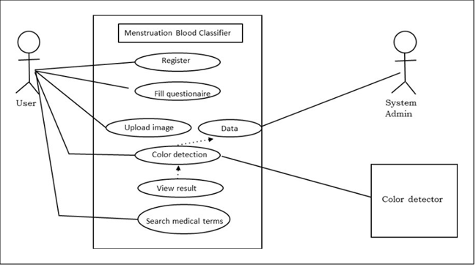

## D. Algorithm analysis

## The color detection algorithm follows the steps, directed as below:

*Step 1*: Procure file that contains our dataset. To create an argument parser, we're drawing the argparse package. The panda's library is really helpful when we need to conduct color related functions on data . For convenient searching, each column has a color code with a name assigned to it.

Step 2: The input image will be displayed in a window that we generate. Additionally, a message function is set to be called whenever a mouse event occurs.

Step 3: Establish a function that determines the pixel's rgb values. The event name (x, y) equals the mouse position in the function parameters. When the event is double-clicked, this algorithm creates and modifies the r, g, and b values as well as the mouse's x and y coordinates.

Step 4: Set up the getColorName function to return the color based on the Pixel value. To determine the color name, we compute a distance(d) that indicates how near we are to the color and select the option with the smallest distance. The formula used to calculate our distance is-

**Distance = pixel_value (Red – ithRedColor)**

**(Green – ithGreenColor) ( Blue – ithBlueColor)**

The color name and pixel values on the window are updated when a user provides image input.

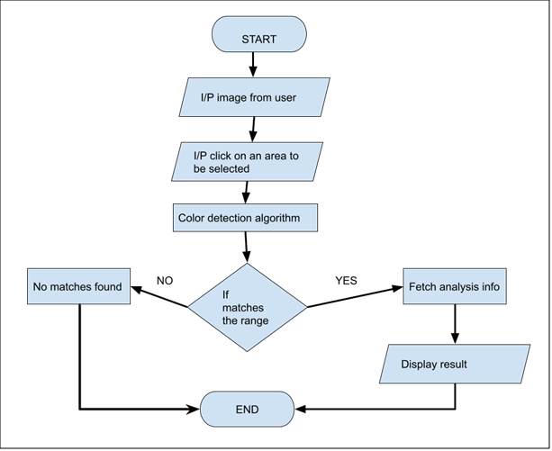

*Figure 2 : Workflow Chart*

# IV. result

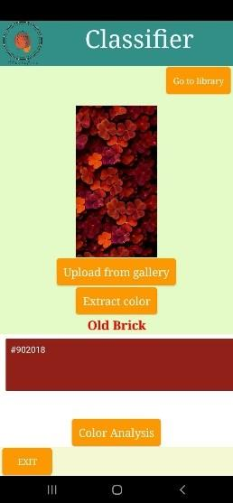

*Figure 3 : Image uploading and detection*



*Figure 4 : Color Analysis*

V. conclusion

This research focuses mostly on the study of graphic processing prototype and color detection and analysis in AI visual automation. We have thoroughly examined the color analysis system and display operation by studying related literature. This paper begins by providing a quick overview of how AI technology works as well as several ideas that are based on its inheritable algorithm. In the end, it examines from three perspectives: the analysis of the current state of color, the satisfaction analysis of color detection and graphic operation in visual media and its health analysis.

The paper's limitations are that the study on related picture applications is still in its early stages and that the use of automation in the creation of visual media is not yet at a sufficiently advanced stage. Research and development still have a lot of room for improvement. Nevertheless, there is still room for creativity and advancement in the color detection and analysis of visual media.

##### 

##### 

##### References

[1] (“What does the color and Texture of Your Menstrual Blood Mean?”)

<https://www.themedicalmassagelady.co.uk/general-information/general-wellbeing/what-does-the-colour-and-texture-of-your-menstrual-blood-mean>

[2] (“Project in Python – Color Detection using Pandas & OpenCV”)

[Project in Python - Color Detection using Pandas & OpenCV -](https://data-flair.training/blogs/project-in-python-colour-detection/)

[DataFlair](https://data-flair.training/blogs/project-in-python-colour-detection/)

[3] (“Semi-supervised support vector machine for digital twins based brain image fusion,-Z. Wan, Y. Dong, Z. Yu, H. Lv, and Z. Lv”)

[4] (“Converging blockchain and next-generation artificial intelligence technologies to decentralize and accelerate biomedical research and healthcare,P. Mamoshina, LOkomoko, Y. Yanovich et al”)

[5](“Artifact-based rendering: harnessing natural and traditional visual media for more expressive and engaging 3D visualizations,S. Johnson, F. Samsel, G. Abram et al.”)